**MEDITATION**

**A SILENT WEEKEND RETREAT**

**FRIDAY 19 MARCH to SUNDAY 21 MARCH 2021**



**Presented by**

**THE BRISBANE THEOSOPHICAL SOCIETY**

**at**

**THE THEOSOPHICAL EDUCATION AND RETREAT CENTRE SPRINGBROOK RD, SPRINGBROOK, QLD**

Please join us in the lovely forest of the Gold Coast hinterland for a weekend of meditation.

Whether you are a beginner or a long-term practitioner, this retreat provides the time and space for the deepening of your meditative practice in order to connect with the stillness within, and to experience the beauty and power of nature.

Silence will be observed from 9pm Friday evening after an information session, until 11.35am prior to a feedback session and lunch on Sunday.  You will have a private room, and all meals are vegetarian.

Check in is from 4.30pm Friday, and departures after lunch on Sunday.

**The cost is $240 for TS Members and $280 for non-members.**

**Registrations close 7 March 2021 and places are limited.**

*Any enquiries should be directed to Phillipa on 0449 887 609*

*or email phillipa.h.rooke@gmail.com*

**What to bring:**Please bring your own single-bed linen, towels, pillow case and bath mat. Chairs only will be available in the meditation hall, so you may also wish to bring your meditation cushion. Also please bring a warm blanket, warm clothing, sturdy walking shoes, umbrella/raincoat, insect repellent & torch.

The Centre is an alcohol and smoke-free zone.

Immerse yourself in a weekend of silence, meditation and nature.

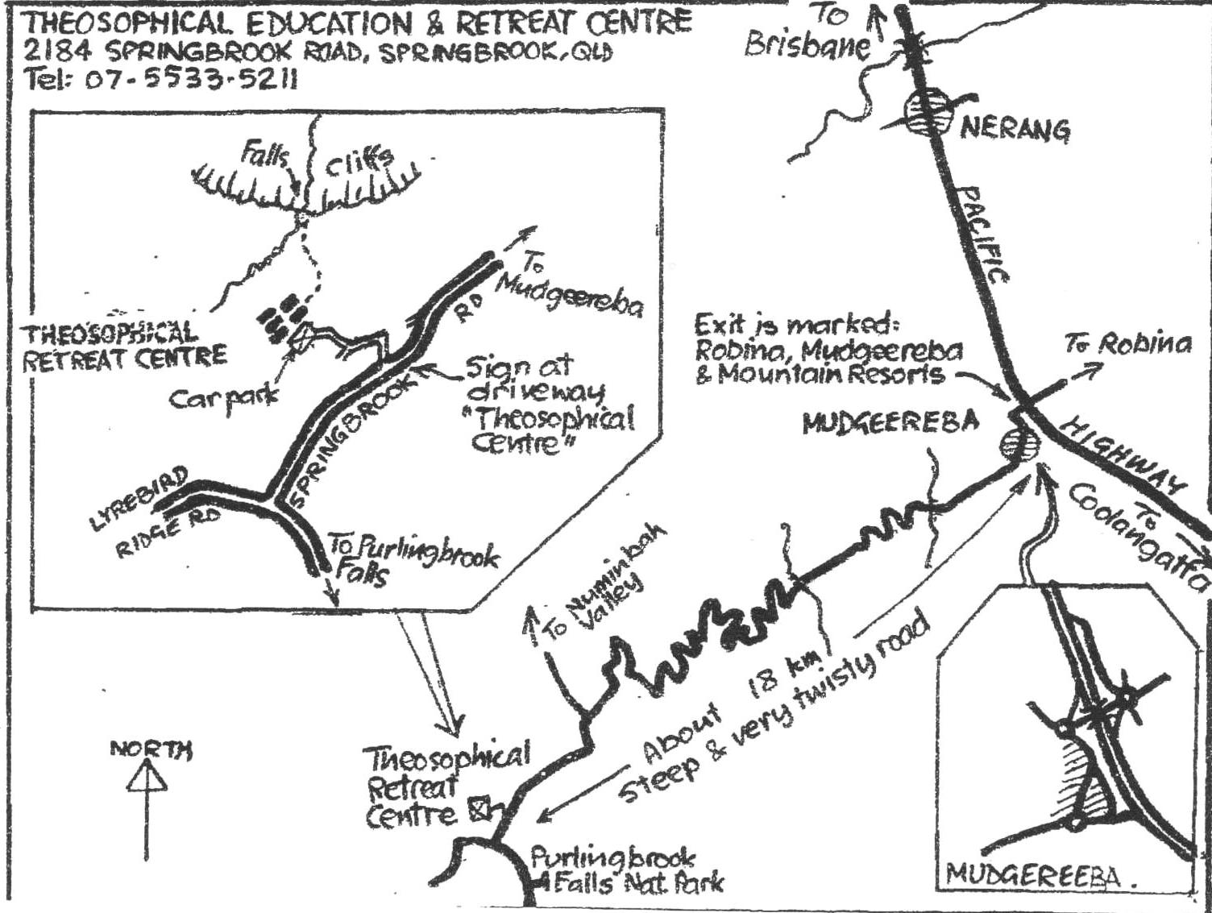

**Registrations close midday 7 March 2021**

**Due to COVID-19 please use contactless payment and registration methods.**

**To register, please pay the full registration amount and submit the completed Registration Form and payment confirmation receipt via email to** [**brisbanelodge@theosophyqld.org.au**](mailto:brisbanelodge@theosophyqld.org.au)**.**

**Scans, screenshots or clear photos are acceptable.**

**Full payment and the form must be received by 7 March 2021 and is required to secure your place.**

**Direct Deposit**

**Account Name Brisbane Theosophical Society, BSB 124030, a/c 10010157, Ref: ‘Retreat [& your surname]’**

**Please send the deposit confirmation with your completed Registration Form by the due date.**

**Cancellations must be received via email to** [**brisbanelodge@theosophyqld.org.au**](mailto:brisbanelodge@theosophyqld.org.au) **before registration closes to receive a full refund. $120 will be withheld if cancelling after close of registration.**

**✀____________________________________________________________________________**

**Registration Form – Springbrook Meditation Retreat 19-21 March 2021**

Name __________________ __

Mobile E-Mail _

Address Postcode Emergency Contact’s Name Phone

Special dietary needs (e.g. gluten/dairy free)

Medical conditions we should be aware of _

If arriving after 6pm on Friday, what time will you arrive and do you require dinner? ___ Yes/No

Please nominate the payment amount which applies to your registration.

**TS Members: I have paid $240 or Non-TS Members: I have paid $280**

**on (date) and include the D/D payment confirmation.**

Signature Date ­­­­­­­­­­